EDS Practical :03
Name: Vighnesh Pingle
PRN: 202501040449
Department: Computer Engineering Division: CS4
Batch: C45 Codetantra practical 3
    - problem statement
Write a Python program to create a NumPy array based on user input and display the following:
      - The created NumPy array.
      - The number of dimensions of the array using ndim
      - The shape of the array using shape
      - The total number of elements in the array using size
Assume all input elements are valid integers.

Input Format:
      - The ﬁrst line contains two space-separated integers, and , representing the number of
rows and the number of columns.

      - The next lines contain space-separated integers representing the elements of the array,
entered row by row.

Output Format:
      - The created NumPy array (printed as a 2D array).
      - An integer representing the number of dimensions of the array.
      - A tuple representing the shape of the array.
      - An integer representing the total number of elements in the array.

Note: Use reshape() function to reshape the input array with the speciﬁed number of rows and columns.

Code:
import numpy as np
r,c = map(int, input().split()) elements = []
for _ in range(r) :

elements.extend(map(int, input().split())) array = np.array(elements).reshape(r,c)

print(array) print(array.ndim) print(array.shape)
print(array.size) Output:
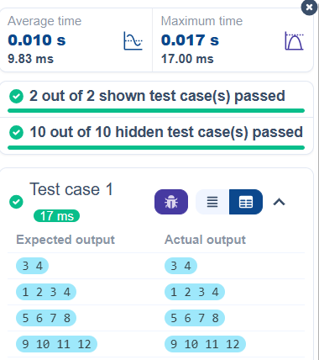

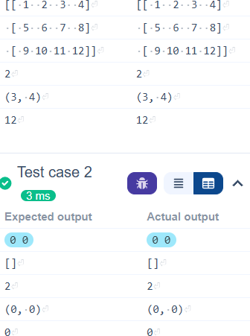

Practical Lab Assignment
    - problem statement
The given code takes two 3 * 3matrices,matrix_a , and matrix_b, as input from the user and converts them into NumPy arrays.

Task:
You are required to compute and display the results of the following matrix operations:

      - Addition (matrix_a + matrix_b)
      - Subtraction (matrix_a – matrix_b)
      - Element-wise Multiplication (matrix_a * matrix_b)
      - Matrix Multiplication (matrix_a . matrix_b)
      - Transpose of Matrix A Input Format:
        - The user will input 3 rows for , each containing 3 integers separated by spaces.
        - Similarly, the user will input 3 rows for , each containing 3 integers separated by spaces.

Output Format:
The program should display the results of the operations in the following order:
- The result of Addition.
- The result of Subtraction.
- The result of Element-wise Multiplication.
- The result of Matrix Multiplication.
- The Transpose of Matrix A. Code:
import numpy as np

# Input matrices print("Enter Matrix A:")
matrix_a = np.array([list(map(int, input().split())) for i in range(3)])

print("Enter Matrix B:")
matrix_b = np.array([list(map(int, input().split())) for i in range(3)])

# Addition addition_result=matrix_a + matrix_b print("Addition (A + B):") print(addition_result)
# Subtraction
subtraction_result = matrix_a - matrix_b print("Subtraction (A - B):") print(subtraction_result)
# Multiplication (element-wise) elementwise_multiplication_result = matrix_a *

matrix_b
print("Element-wise Multiplication (A * B):") print(elementwise_multiplication_result)
# Matrix multiplication (dot product)
matrix_multiplication_result =np.dot(matrix_a, matrix_b)
print("A dot B:") print(matrix_multiplication_result) # Transpose
transpose_a = matrix_a.T print("Transpose of A:") print(transpose_a)

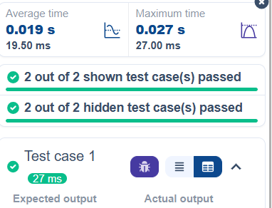

_J
Enter-Matrix-A:

Enter•Matrix•A:

1 2 3 | 1 | 2 | 3
4 5 6 | 4 | 5 | 6
7 8 9 | 7 | 8 | 9
Enter,Matrix-B: Enter·Matrix-B:
L

1 | 1 | 1 | 1 | 1 | 1
1 | 1 | 1 | 1 | 1 | 1
1 | 1 | 1 | 1 | 1 | 1

Addition·(A·+·B):

[[·2-,3--4]
·[·5-,6--7]
• [ • 8 • • 9 • 10 ] ]
Subtraction·(A·-·
B):
[[0·1·2]
- [3·4·5]
· [6-7,8]]

Element-wise-Multip lication•(A·*·B):
[[-2--3,-4]
·[·5·•6°•7]
·[·8··9·10]]
Subtraction·(A·-·
B):
[[0-1-2]
·[3·4-5]
·[6,7-8]]
Element-wise-Multi plication·(A·*·B):

[[1·2·3]
- [4-5,6]
- [7-8,9]]
A·dot·B:
[[·6··6··6]
·[15-15-15]
[[1·2·3]
·[4,5-6]
- [7,8-9]]
A·dot·B:
[[-6··6··6]
·[15-15-15]

7

_J
- [24-24-24]]
Transpose-of-A:
[[1·4·7]
·[2-5,8]
·[3-6-9]]

-r:est case 2
0
lfii,1�--
Expected output Enter,Matr-ix·A: 2 4 8
9 6 5
7 8 9
Enter,Matr-ix-B:

L
• [ 24 • 24 • 24] ]
Transpose-of-A:
[[1·4-7]
·[2,5-8]
·[3·6-9]]



Actua output
Enter-Matrix-A:
2 4 8
9 6 5
7 8 9
Enter-Matrix-13:

10 12 | 13 | 10 12 13
14 15 | 16 | 14 15 16
17 18 | 19 | 17 18 19

Addition-(A·+·B):

[[12-16-21]
·[23-21-21]
- [ 24 • 26 • 28 ]]
Subtraction-(A·-·
B):
[[·-8· ·-8··-5]
·[·-5· ·-9·-11]
[[12-16·21]
·[23-21,21]
- [24-26·28]]
Subtraction·(A·-·
B):
[ [ • -8 • • -8 • • - 5]
·[·-5··-9·-11]

7

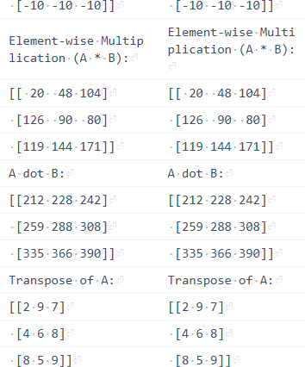
    - problem statement
You are given two arrays arr1 and arr2. You need to perform horizontal and vertical stacking operations on them using NumPy.
- Horizontal Stacking: Stack the two matrices horizontally (side by side).
- Vertical Stacking: Stack the two matrices vertically (one below the other).

Input Format:
- The program should ﬁrst prompt the user to

input two 3x3 arrays.
- Each array consists of 3 rows, and each row contains 3 space-separated integers.
- The user will input the two arrays row by row.

Output Format:
- The program should display the result of the Horizontal Stack (side-by-side stacking) of the
two arrays.
- The program should then display the result of the Vertical Stack (one below the other) of the
two arrays.

Code:
import numpy as np

# Input matrices print("Enter Array1:")
arr1 = np.array([list(map(int, input().split())) for i in range(3)])
print("Enter Array2:")
arr2 = np.array([list(map(int, input().split())) for i

in range(3)])
# Perform horizontal stacking (hstack) a=np.hstack((arr1,arr2)) print("Horizontal Stack:")
print(a)

# Perform vertical stacking (vstack) b=np.vstack((arr1,arr2)) print("Vertical Stack:")
print(b)

Output:
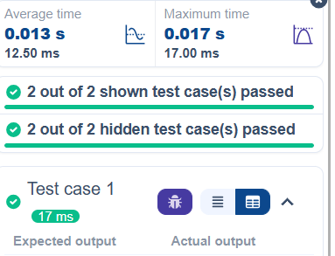

_J
Enter·Arrayl:

L
Enter-Array1:

1 | 2 3 | 1 2 3
4 | 5 6 | 4 5 6
7 | 8 9 | 7 8 9

Enter•Array2:
4 5 6
7 8 9
10 11 12
Horizontal-Stack:
[[ ·1· ·2· .3 .. 4 .. 5. ·
6]
• [·4· .5. ·6· .7. ·8· •
9]
•[-7•·8-·9-10-11-1
2]]
Vertical-Stack:
[[·1··2··3]
·[·4··5··6]
·[-7-,8··9]
·[·4··5··6]
·[-7••8··9]
·[10-11-12]]
Enter•Array2:
4 5 6
7 8 9
10 11 12
Hori�ontal·Stack:
[[-1· ·2· .3 .. 4. · 5. ·
6]
·[·4· .5. ·6· .7. ·8· •
9]
• [ • 7 • • 8 • • 9 • 10 • 11 • 1
2]]
Vertical-Stack:
[[-1··2··3]
·[·4··5··6]
·[·7··8,,9]
·[·4--5 .. 6]
·[•7•-8··9]
- [10-11-12]]


17est case 2

0

Expected output Actual output

7

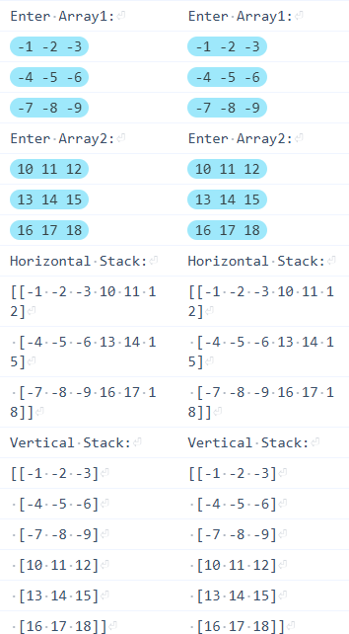

    - problem statement
Write a Python program that takes the following inputs from the user:
- Start value: The starting point of the sequence.
- Stop value: The sequence should end before

this value.
- Step value: The increment between each number in the sequence.
The program should then generate a sequence using numpy based on these inputs and print the generated sequence.

Input Format:
- The user will input three integer values: start, stop, and step, each on a new line.

Output Format:
- The program should print the generated sequence based on the input values.

Code:
import numpy as np

# Take user input for the start, stop, and step of the sequence
start = int(input()) stop = int(input())

step = int(input())

# Generate the sequence using np.arange() a=np.arange(start,stop,step)
print(a)
# Print the generated sequence Output:
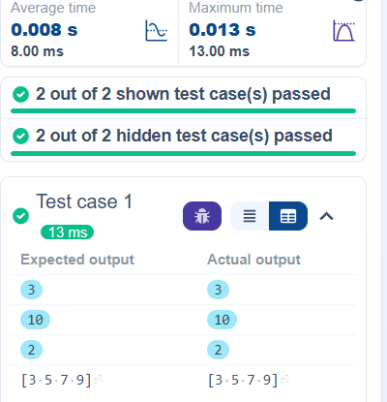

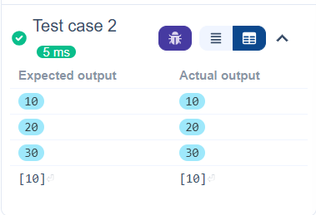
    - problem statement
You are given two arrays A and B. Your task is to complete the function array_operations, which will convert these lists into NumPy arrays and perform the following operations:

- Arithmetic Operations:
  - Compute the element-wise sum, difference, and product of the two arrays.
- Statistical Operations:
  - Calculate the mean, median, and standard deviation of array A.
- Bitwise Operations:
  - Perform bitwise AND, bitwise OR, and bitwise XOR on the arrays (ex: Ai OR Bi).

Input Format:
  - The ﬁrst line contains space-separated integers representing the elements of array A.
  - The second line contains space-separated integers representing the elements of array B.

Output Format:
  - For each operation (arithmetic, statistical, and bitwise), print the results in the speciﬁed
format as shown in sample test cases.

Code:
import numpy as np

def array_operations(A, B):

# Convert A and B to NumPy arrays
A = np.array(A)
B = np.array(B)
# Arithmetic Operations sum_result = A + B diff_result = A - B

prod_result = A * B

# Statistical Operations mean_A = np.mean(A) median_A = np.median(A) std_dev_A = np.std(A)

# Bitwise Operations and_result = A & B or_result =A | B xor_result = A ^ B
# Output results with one space between each element
print("Element-wise Sum:", ' '.join(map(str, sum_result)))
print("Element-wise Difference:", ' '.join(map(str, diff_result)))
print("Element-wise Product:", ' '.join(map(str, prod_result)))

print(f"Mean of A: {mean_A}") print(f"Median of A: {median_A}")

print(f"Standard Deviation of A: {std_dev_A}")
print("Bitwise AND:", ' '.join(map(str, and_result)))
print("Bitwise OR:", ' '.join(map(str, or_result))) print("Bitwise XOR:", ' '.join(map(str, xor_result)))

A = list(map(int, input().split())) # Elements of array A
B = list(map(int, input().split())) # Elements of array B
array_operations(A, B) Output:
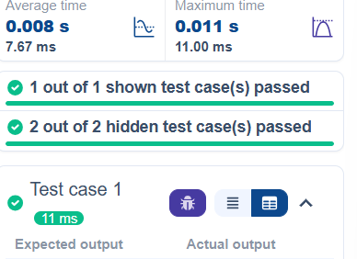

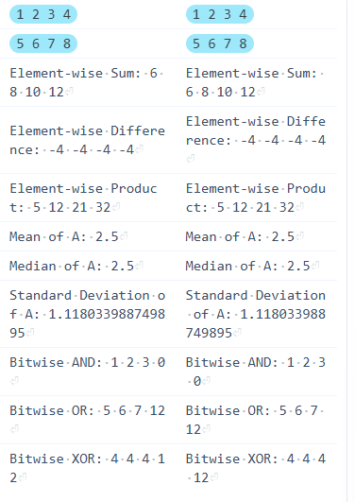
    - problem statement
The given code takes a list of integers as input and converts it into a NumPy array. Your task is to complete the code by:
- Creating a view of the original_array and assigning it to view_array.
- Creating a copy of the original_array and assigning it to copy_array.

After completing these steps, observe how modifying the view affects the original_array, while modifying the copy does not.

Input Format:
- A single line of space-separated integers.

Output Format:
- After modifying the view:
Original array after modifying view: <original_array> View array: <view_array>
- After modifying the copy:
Original array after modifying copy: <original_array> Copy array: <copy_array>

Code:
import numpy as np

inputlist = list(map(int,input().split(" ")))

# Original array
original_array = np.array(inputlist)

# Create a view
view_array =original_array.view()

# Create a copy
copy_array =original_array.copy()

# Modify the view view_array[0] = 99
print("Original array after modifying view:", original_array)
print("View array:", view_array) # Modify the copy copy_array[1] = 88
print("Original array after modifying copy:", original_array)
print("Copy array:", copy_array)

Output:

L
_J
Average time  0.005 s  4.75 ms | � | Maximum time  0.010 s  10.00 ms

0
ti
O 2 out of 2 shown test case(s) passed

O 2 out of 2 hidden test case(s) passed


17est case 1

0

Expected output
10 20 30 40 50 6
0 80
Original-array-after
·modifying-view:·[99
·20-30-40-50-60-70-8
0]

View•array:•[99·20·3
0,40,50-60-70,80]

Original-array-after
-modifying-copy:•[99
·20·30·40·50·60·70·8
0]

Copy·array:·[10-88·3
0-�0-50-60-70•80]
Actual output
10 20 30 40 50 6
0 80
Original•array•af ter·modifying,vie w:-[99-20-30-40-5 0-60-70-80]
View·array:·[99·2
0-30-40-50-60-70-
80]
Original·array-af ter-modifying-cop y:·[99·20·30-40·5 0,60-70-80]
Copy-array:•[10-8
8·30-40-50-60·70·
80]


17est case 2
0
.,,1.

7

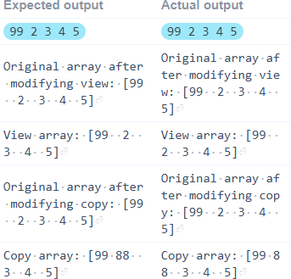
    - problem statement
The given code in the editor takes a single
array, array1, as space-separated integers as input from the user.
Additionally, it takes the following inputs:
- search_value: The value to search for in the array.
- count_value: The value to count its occurrences in the array.
- broadcast_value: The value to add for broadcasting across the array.

You need to complete the code to perform the following operations:

- Searching: Find the indices
where search_value appears in array1 and print these indices.
- Counting: Count how many
times count_value appears in array1 and print the count.
- Broadcasting: Add broadcast_value to each element of array1 using broadcasting, and print the resulting array.
- Sorting: Sort array1 in ascending order and print the sorted array.
Input Format:
  - A single line containing space-separated integers representing array1.
  - An integer search_value represents the value to search for in the array.
  - An integer count_value represents the value to count in the array.
  - An integer broadcast_value represents the value to add to each element of the array.

Output Format:
- The indices where search_value occurs

in array1.
- The count of occurrences of count_value in array1.
- The array after adding the broadcast_value to each element.
- The sorted array.

Code:
import numpy as np

# Input array from the user
array1 = np.array(list(map(int, input().split())))

# Searching
search_value = int(input("Value to search: ")) count_value = int(input("Value to count: ")) broadcast_value = int(input("Value to add: ")) # Find indices where value matches in array1 a=np.where(array1==search_value)[0] print(a)
# Count occurrences in array1

b=np.count_nonzero(array1==count_value) print(b)
# Broadcasting addition c=array1 + broadcast_value print(c)
# Sort the ﬁrst array d=np.sort(array1) print(d)
Output:
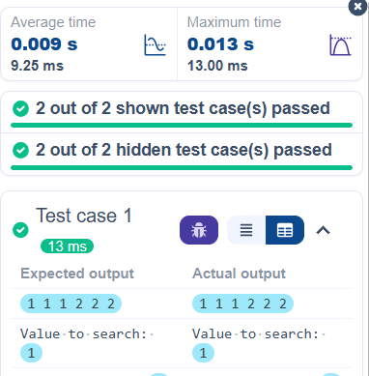

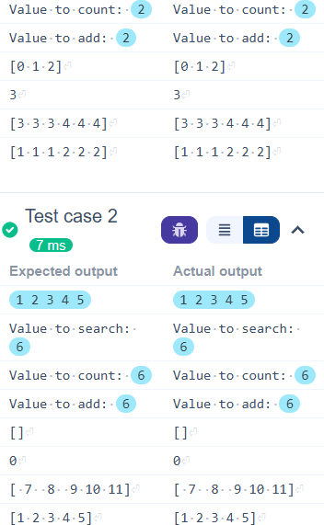

    - problem statement
Write a Python program that takes the ﬁle name of a CSV ﬁle containing student details, including roll numbers and their marks in three subjects as input, reads the data, and performs the following operations:
- Print all student details: Display the complete

details of all students, including roll numbers and marks for all subjects.
- Find total students: Determine the total number of students in the dataset.
- Print all student roll numbers: Extract and print the roll numbers of all students.
- Print Subject 1 marks: Extract and print the marks of all students in Subject 1.
- Find minimum marks in Subject 2: Identify the lowest marks in Subject 2.
- Find maximum marks in Subject 3: Identify the highest marks in Subject 3.
- Print all subject marks: Display the marks of all students for each subject.
Find total marks of students: Compute the total marks for each student across all subjects..
- Find the average marks of each student: Compute the average marks for each student.
- Find average marks of each subject: Compute the average marks for all students in each
subject.
- Find average marks of Subject 1 and Subject 2: Compute the average marks for Subject 1 and
Subject 2.

- Find average marks of Subject 1 and Subject 3: Compute the average marks for Subject 1 and
Subject 3.
- Find the roll number of students who scored 24 marks in Subject 2: Identify students who
obtained exactly 24 marks in Subject 2 and print their roll numbers.
- Find the count of students who got less than 40 marks in Subject 1: Count the number of
students who scored less than 40 marks in Subject 1.
- Find the count of students who got more than 90 marks in Subject 2: Count the number of
students who scored more than 90 marks in Subject 2.
- Find the count of students who scored >=90 in each subject: Count the number of students
who scored 90 or more marks in each subject.
- Find the count of subjects in which each student scored >=90: Determine how many
subjects each student scored 90 or more marks in.
- Print Subject 1 marks in ascending order: Sort and print the marks of students in Subject 1 in
ascending order.

- Print students who scored between 50 and 90 in Subject 1: Display students who scored
marks between 50 and 90 in Subject 1.
- Find index positions of students who scored 79 in subject 1:Identify the index positions of
students who scored exactly 79 marks in subject 1.

Code:
import numpy as np

a = np.loadtxt("Sample.csv", delimiter=',', skiprows=1)
# 1. Print all student details print("All student Details:\n", a) # 2. print total students
print("Total Students:", a.shape[0]) # 3. Print all student Roll numbers print("All Student Roll Nos", a[:, 0]) # 4. Print subject 1 marks
print("Subject 1 Marks", a[:, 1])
# 5. print minimum marks of Subject 2

print("Min marks in Subject 2", np.min(a[:, 2])) # 6. print maximum marks of Subject 3 print("Max marks in Subject 3", np.max(a[:, 3])) # 7. Print All subject marks
print("All subject marks:", a[:, 1:])
total = np.sum(a[:, 1:], axis=1)
# 8. print Total marks of students print("Total Marks", total)
#(no label in sample output) print(np.round(np.mean(a[:, 1:], axis=1), 1)) # 9. print average marks of each student
# 10. print average marks of each subject
print("Average Marks of each subject", np.round(np.mean(a[:, 1:], axis=0), 1))

# 11. print average marks of S1 and S2
print("Average Marks of S1 and S2", np.round(np.mean(a[:, [1, 2]], axis=0), 1))
# 12. print average marks of S1 and S3
print("Average Marks of S1 and S3", np.round(np.mean(a[:, [1, 3]], axis=0), 1) )

# 13. print Roll number who got maximum marks in Subject 3
print("Roll no who got maximum marks in Subject 3", a[np.argmax(a[:, 3]), 0])
# 14. print Roll number who got minimum marks in Subject 2
print("Roll no who got minimum marks in Subject 2", a[np.argmin(a[:, 2]), 0])
# 15. print Roll number who got 24 marks in Subject 2
print("Roll no who got 24 marks in Subject 2", a[a[:, 2] == 24, 0].reshape(-1,1))
# 16. print count of students who got marks in Subject 1 < 40
print("Count of students who got marks in Subject 1 < 40", np.sum(a[:, 1] < 40))
# 17. print count of students who got marks in Subject 2 > 90
print("Count of students who got marks in Subject 2 > 90:", np.sum(a[:, 2] > 90))
# 18. print count of students in each subject who got marks >= 90
print("Count of students in each subject who

got marks >= 90:",
np.sum(a[:, 1:] >= 90, axis=0))
# 19. print count of subjects in which each student got marks >= 90
print("Roll no:", a[:, 0])
print("Count of subjects in which student got marks >= 90:",
np.sum(a[:, 1:] >= 90, axis=1))
# 20. Print S1 marks in ascending order print(np.sort(a[:, 1]))
# 21. Print S1 marks >= 50 and <= 90 print(a[(a[:, 1] >= 50) & (a[:, 1] <= 90)])
print(a)
# 22. Print the index position of marks 79 print(np.where(a[:, 1] == 79))
Output:

V
L
_J
Average time |  | Maximum time
0.014 s  14.00 ms | � | 0.014 S,  14.00 ms

�

O 1 out of 1 shown test case(s) passed


0 lest case 1
- Eln�i
Expected output
All-student-Details:

• [[301. • • 67. • • 77. • • 8
8.]
• [ 302. • • 78. • • 88 . • • 7
7.]
• [ 303. • • 45. • • 56. • • 8
9.]
• [ 304. • • 88. • • 98 . • • 4
5.]

Actual OUq)Ut

All-student-Detai ls:
• [ [ 3 01. • • 67 . • • 77 .
• • 88.]
• [ 3 02. • • 78 . • • 8 8 . •
,77_]

• [303. • ·45. • ·56. •
,89.]
• [ 304. • • 88 . • • 9 8 . •
,45.J

7

_J
• [ 305 . • • 78. • • 88 . • • 9 9.]
• [ 306. • • 68. • • 78. • • 3
6.]
• [307. • ·79. • ·12. • ·4 5.]
• [308. -• 46. -• 45. • .7
7.]
• [309. • ·89. • ·32. • ·8
8.]
• [310. -• 79. -• 24. • .3
3.]]

Total·Students:-10

All·Student·Roll·Nos
·[301.-302.-303.·30
4. • 305. • 306. • 307. • 30
8. • 309. • 310.]

Subject•l•Marks-[67.
• 78. • 45. • 88. • 78. • 68.
• 79 . • 46 . • 89 . • 79 . ]

Min·rnarks·in·Subject
·2-12.0
Max-rnarks-in-Subject
-3-99.0

All·subject·rnarks:· [[67.·77.·88.]

L
• [305. • ·78. • ·88. •
·99.]
·[306. -• 68. -• 78.,
-36.J
• [ 307. • • 79. • • 12. •
·45.]
• [ 308. • • 46 . • • 45 ,.
. 77. J
• [ 309. • • 89. • • 32. •
·88.]
·[310. -• 79. • ·24.,
- 33.]]
Total·Students:·1
0
All·Student·Roll·
Nos-[301.-302.·30
3. • 304. • 305. • 306.
·307. ·308. ·309 .•3 10.]
Subject-1-Marks•
[67-. 78.-45.-88.,
78. • 68 . • 79 . • 46 . • 8
9.-79.]
Min-marks-in-Subj ect-2·12.0
Max-marks-in-Subj
ect-3-99.0
All-subject-mark
s:·[[67.·77.·88.]

7

_J L

•[78.•88.•77.]
·[45.,56.,89.]
·[88.,98.,45.]
•[78.•88.•99.]
·[68.·78.·36.]
•[79.•12.•45.]
·[46.,45.,77.]
•[89.• 32.•88.]
•[79.•24.• 33.]]
Total•Marks-[232.•24
3.•190.•231.•265.•18
2.. -136. • 168.·209.,13
6.]

[77.3-81.•-63.3-77.•
·88.3·60.7-45.3-56.•
-69.7,45.3]

Average-Marks of-eac h•subject,[71.7•59.8
-67.7]

Average·Marks·of·S1· and-S2-[71.7-59.8]

Average·Marks·of·S1· and-S3-[71.7-67.7]

Roll-no-who-got-maxi mum•marks,in•Subject
-3-305.0
·[78.-88.•77.]
,[45.-56.-89.]
,[88.·98.·45.]
- [78.·88.·99.]
- [ 68.•78.•36.]
· [79. ·12.•45.]
,[ 46..45.·77.]
- [89.·32.-88.]
- [79. • 24.•33.]]
Total-Harks-[232..
·243.·l.90.·231.·2 65.·182.,136. • 16
8.•209.•136.]
[77.3-81. ·63.3•7
7.--88.3-60.7-45.
3-56.•·69.7-45.3]

Average-Marks-of, each•subject,[71. 7-59.8-67.7]
Average-Marks-of· S1-and·S2•[71.7•5 9.8]
Average-Marks-of, S1-and·S3•[71.7•6 7.7]
Roll·no-who-got·m aximum•marks,in·S ubject-3-305.0

7

_J
L
w

Roll-no-who-got-mini mum·marks·in·Subject
·2-307.0
Roll-no-who-got-2.4-m arks·in·Subject·2.· [[310.]]

Count,of·students,wh o•got•rnarks•in•Subje ct·1·<·40·0

Count,of•students,wh o·got·rnarks·in·Subje ct-2·>·90:-11.

Count-of-students-in
  - each,subject,who,go t·rnarks·>=-90:·[0·1·
1]
Roll-no:•[301.•302.• 303.•304.• 305. •306.•
307.·308.,309.·310.]

Count·of-subdects·in
-which-student-got-m arks·>=·90:·[0·0·0·1
·1·0·0·0·0·0]

[ 45 . • 46 . • 67 . • 68 . • 78 .
•78.•79.•79.• 88 . • 8
9.]
[ [ 301.• •67.••77.• ,8
8 - ]
•[ 302.• • 78. • •88.• ,7
Roll-no-who-got-111 inimum·marks·in·S ubject-2.-307.0
Roll•no•who•got•2 4-marks·in·Subjec t-2·[[310.]]
Count-of-students
·who·got·rnarks·in
-Subject•1·<·40-0

Count-of-students
,who,got,rnarks-in
•Subject•2·>·90:•
1
Count-of-students
,in•each,subject, who-got-marks->=· 90:•[ 0 •1 •1]
Roll•no:•[301.·30
2.•303.•304.• 305.
,306.•307.•308.•3 09.•310.]
Count-of-subjects
- in-which-student
,got,marks·>=-90:
·[0·0·0·1·1·0·0·0
·0·0]
[ 45. • 46,. • 67. • 68. •
78.•78.•79.•79.• 8
8.·89.]
[[301.··67.· ,77. ,
·88.]
,[302.·-78.·,88.,

7

_J
9.]
·[l06.··68.··78.· ·3
6.]
• [ 307 . • • 79. • • 12 . • • 4
5.]
• [ 309 . • • 89. • • 32 . • •8
8.]
• [310. -• 79. -• 24. • .3
3.]]
[ [301. • • 6 7. • • 77 . • •8
8.]
• [ 302.. • • 78 . • • 88 . • • 7 7 - ]
• [303. -• 45. -• 56. • ·8
9.]
• [ 304 . • • 88. • • 98 . • • 4
5.]
• [ 305 . • • 78. • • 88 . • • 9
9.]
·[l06.--68.--78.· ·3
6.]
• [ 307 . • • 79. • • 12 . • • 4
5.]
• [ 308. • • 46. • • 45 . • • 7
7 - ]
• [309. -• 89. -• 32. • ·8
8.]
• [310. -• 79. -• 24. • .3
3.]]
(array([6,-9],-dtype
=int32),)

L
·99.]
• [306. -• 68. • ·78. •
- 36.]
- [ 307. • • 79. • •12. •
-45.]
- [ 309. • • 89. • • 32. •
-88.J
- [ 310. • • 79. • • 24. •
·33.]]
[[ 301. • • 6 7 . • • 77 . •
-88.J
- [ 302. • • 78. • • 88. •
·77.]
- [303. • ·45. • ·56. •
-89.J
- [304. -• 88. -• 98. •
·45.]
- [305. -• 78. • ·88. •
-99.J
- [ 306. • • 68. • • 78. •
- 36.]
- [307. • • 79. • •12. •
-45.J
- [ 308. • • 46. • • 45. •
-77.]
- [ 309. • • 89. • • 32. •
-88.J
- [ 310. • • 79. • • 24. •
·33.]]
(array([6, ·9], ·dt ype=int32.)3)

7

